LAO PDR GENERAL DISABILITY OVERVIEW
SEPTEMBER 2012

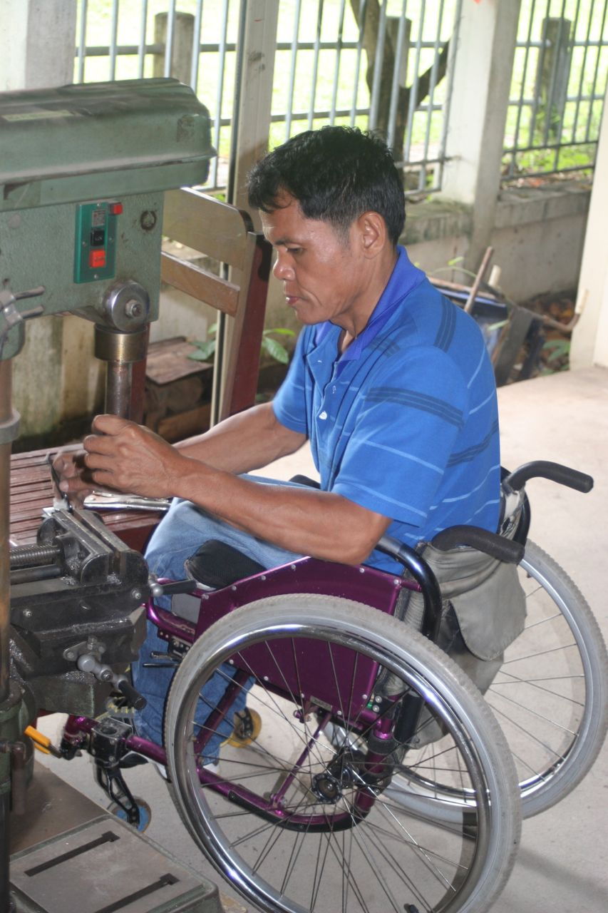
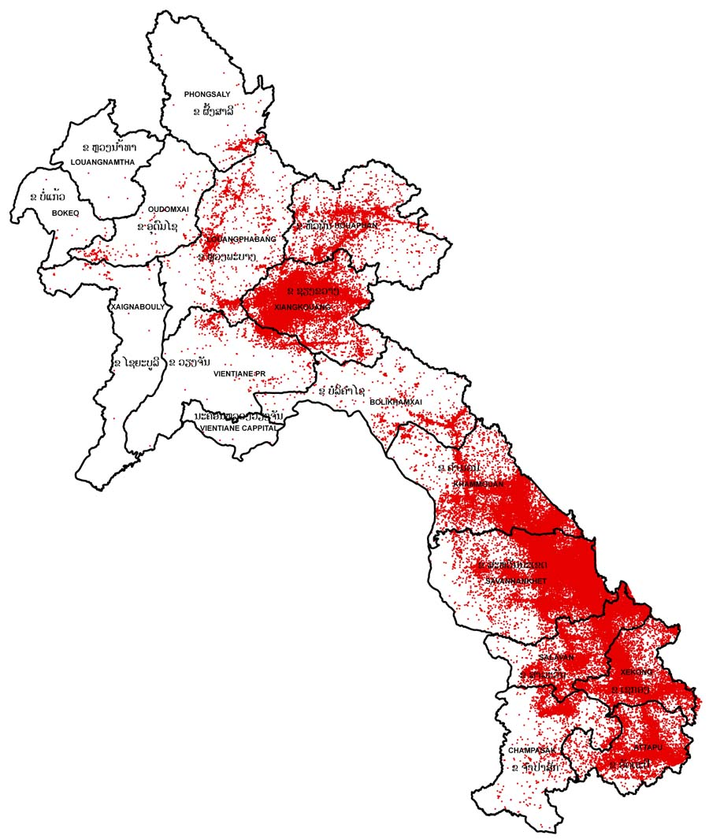

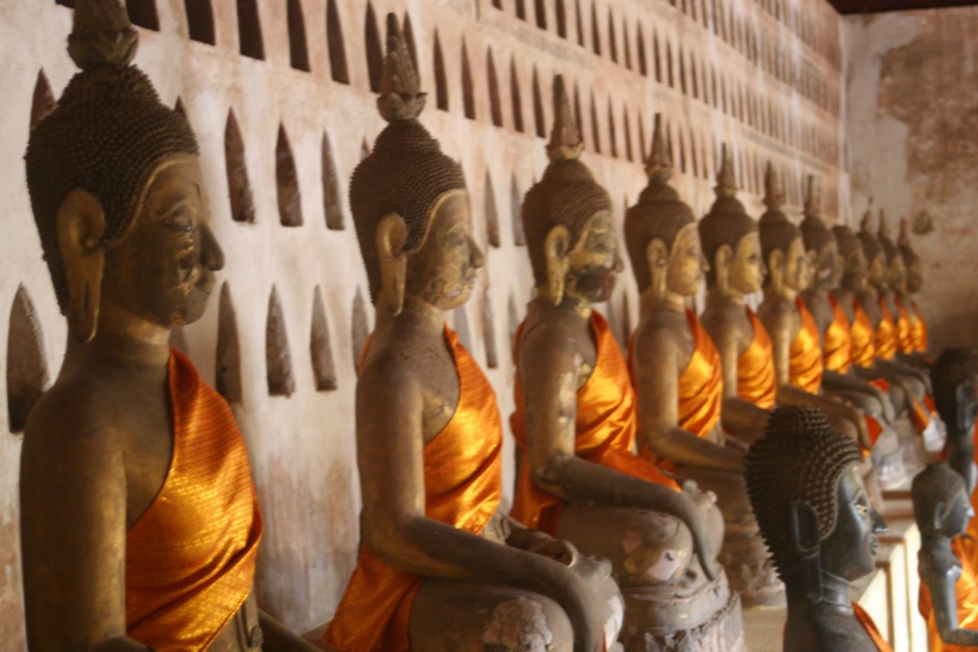

Susan Eitel, USAID
DCHA/DRG/SPANS

Acronyms
AAR Association for Aid and Relief
CBM Christoffel Blindenmission
CBR Community-Based Rehabilitation
CCM Convention on Cluster Munitions
CMR Center for Medical Rehabilitation (formerly NRC)
COPE Cooperative Orthotic and Prosthetic Enterprise
CSPO Cambodian School of Prosthetics and Orthotics
CWD Children with Disabilities
DCHA Department of Conflict and Humanitarian Affairs
DIC Deseret International Charities
DPO Disabled People’s Organization
DRG Democracy Rights and Governance
ERW Explosive Remnants of War
GOL Government of Lao PDR
HIF Handicap International
ICRC International Committee of the Red Cross
ISPO International Society for Prosthetics and Orthotics
JICA Japanese International Cooperation Agency
LDPA Lao Disabled People’s Association
LDWDC Lao Disabled Women’s Development Centre
LWU Lao Women’s Union
LWVF Leahy War Victims Fund
MLSW Ministry of Labor and Social Welfare
MoE Ministry of Education
MoH Ministry of Health
MoU Memorandum of Understanding
MRE Mine Risk Education
MVA Motor Vehicle Accident
NCDP National Committee for Disabled People
NGO Non-governmental Organization
NRA National Regulatory Authority (for UXO/Mine Action in Lao PDR)
NRC National Rehabilitation Centre
OT Occupational Therapy
PDR Peoples Democratic Republic
P&O Prosthetics and Orthotics
PT Physical Therapy
PWD People with Disabilities
SPANS Special Programs Addressing Needs of Survivors
TWG Technical Working Group
UNCRPD Convention on the Rights of Persons with Disabilities
USAID United States Agency for International Development
UXO Unexploded Ordnance
VA Victim Assistance
VIETCOT Vietnam College of Orthopedic Technologists
WC Wheelchair
WSTP Wheelchair Service Training Package
WHO World Health Organization

Table of Contents Page

- Executive Summary…………………………………………………………………………….. 3
- Country Background……………………………………………………………………………. 3
- Policy Environment and Coordination for Disability…………………………….. 4
- Disabled People’s Organizations………………………………………………………….. 4
- Human Resources and Training……………………………………………………………. 5
- National Regulatory Agency and Victim Assistance………………………………. 6
- Physical Rehabilitation Services……………………………………………………………. 6
- Inclusive Education and Employment for Persons with Disabilities………… 8
- Conclusion…………………………………………………………………………………………….. 8

Attachments:
Map of Lao PDR
Contact information

- Executive Summary

Susan Eitel, DCHA/DRG/SPANS, visited Lao PDR from September 19-27, 2012. Visit objectives:
- Review two projects supported by United States Agency for International Development (USAID)
- Collect up-to-date information on disability in Lao PDR.
Information from the project visits is captured separate reports and not included in this document.

During the visit, Ms. Eitel met with 13 different stakeholders/organizations (all within Vientiane). A list of contacts/organizations is provided in Attachment 2.

Key impressions / information from the visit:
- Injuries from unexploded ordnance are decreasing; motor vehicle accidents are on the rise.
- There are no long-term care options or services for people with spinal cord injury.
- Coordination through the National Committee for Disabled People (NCDP) is nascent and weak.
- Laos has signed key international treaties but has yet to finalize a National Decree on Disability.
- Wheelchair production and delivery services exist, but require further capacity development.
- There are no higher education opportunities for the Deaf; vocational training is limited.
- Ponseti method used to clubfoot in children under age 3; follow-up is rare – outcomes unknown.
- Physical Therapy (PT) School in Vientiane is functional; Occupational Therapy (OT) doesn’t exist.
- Prosthetists/Orthotists are trained in VIETCOT/CSPO; Laos plans to open a course in late 2012.
- There are six physical rehabilitation centers in Laos (5 are Ministry of Health/COPE partnership).
- Within MoH, commitment to quality mobility device production and service provision is low.

Key recommendations:
- Work with MoH to identify ways to increase rehabilitation staff’s commitment to quality service.
- Emphasize follow-up and impact of interventions related to physical rehabilitation.
- Support further wheelchair developments, with focus on postural support for children.
- Invest in long-term care options for people with spinal cord injuries.
- Reinforce coordination efforts / policy development through the NCDP.

- Country Background
Lao PDR has 17 provinces (see map Attachment 1) and a population of 6.6 million people. According to World Health Organization, roughly 15% of a population has a disability; with this formula, there are an estimated 990,000 people with disability (PWD) in Laos. Although a survey of mine/UXO victims was made in 2010 (revealing 50,370 casualties) with this information and balancing attrition rates with new injuries, there and an estimated 11,500 mine/ERW survivors alive today, the- re has been no survey conducted for general disability in Laos.

Lao PDR is, per capita, the most heavily bombed nation in the world. Throughout the 1964-1973 Second Indochina conflict, it suffered intensive aerial bombardment and extensive ground battles. Records indicate that in excess of two million tons of bombs were dropped on Lao PDR (approximately one ton of ordnance for every man, woman, and child), including more than 270 million cluster sub-munitions, commonly referred to as “bombies” – up to 30% of cluster munitions failed to detonate upon impact.
Although the incidence of UXO-related injuries is on the decline (see Section 7), the number of road traffic accidents is increasing. In 2011 there were 99 UXO incidents whereas there were over 900 fatalities and 11,604 injuries from road traffic accidents. Handicap International (HI) is engaged in a Road Safety Awareness Project introducing road safety curriculum in 14 primary schools in Savannaket and Vientiane.

In addition to trauma-related injuries, disabilities are caused by disease (Laos still has a leprosy problem as well as residual impairments from polio), and are also seen at birth (club foot, spina bifida and cerebral palsy to name a few).

In sum, although Lao PDR is known for its UXO contamination and related injuries, there is a broader disability environment that needs to be considered in regard to future investment and interventions.

- Policy Environment and Coordination for Disability
Lao PDR signed the Convention on Cluster Munitions (CCM) on 3 December 2008, and ratified on 18 March 2009. It also hosted the First Meeting of States Parties on November 9-12, 2010.

Lao PDR has not acceded the Mine Ban Treaty, but reported on Article 7 in July 2011 (first time).

Lao PDR signed the United Nations Convention of the Rights of Persons with Disabilities (UNCRPD) on 15 January 2008, and ratified on 25 September 2009. The Government has yet to send their report to the UN (it is one year overdue).

The draft Decree on Disability was drafted in 2008 and is still pending government approval.

In 2009, the government of the Lao PDR issued a decree authorizing Non Profit Associations to register and operate.

There are discussions about the inclusion of disability questions in the 2015 census; nothing firm.

The Ministry of Education (MoE) has adopted a National Strategy and Plan of Action on Inclusive Education (2011-2015).

The National Committee for Disabled People (NCDP) was established in 1995 to coordinate disability-related activities between various ministries. The NCDP is led by the Ministry of Labor and Social Welfare (MoLSW) and is to have over ten ministries represented. The NCDP has held three coordination meetings (July, August, September 2012). Meetings will continue to be held monthly.

- Disabled People’s Organizations
The Lao Disabled Persons Association (LDPA) was constituted on 20 July 2001, in Vientiane Capital. It has eleven provincial branch offices, 5,400 members and comprises six disability organizations. These organizational members include:
- Lao Disabled Women’s Development Center (LDWDC)
- Lao Association of the Blind (LAB)
- Association for Autism (AA)
- Cerebral Palsy Unit – Ban San Souk School (BSS)
- Deaf and Hard of Hearing Unit (DHHU)
- Intellectual Disability Unit (IDU)
LDPA has recently been recognized as a Non-Profit Association, and has developed a 2012-2015 strategy. Objectives: respond to PWD needs, promote participation of PWDs, and strengthen LDPA.

LDPA has received capacity building support from POWER (2000-2010), from Handicap International (economic activities, awareness raising, and a new project of DPO capacity building through the US State Department from August 2012-through July 2014), AusAID volunteers, and AAR/JICA will be providing LDPA with a new office by the end of 2012 (unclear if this will also include a wheelchair repair service?).

Lao Ban Advocates is a small group of cluster munitions survivors that came together with support from HI/LDPA to assist in rising awareness in Lao PDR on cluster munitions.

World Education supported the formation of Quality of Life Association (QLA). It was recognized in September 2011 as a Non-Profit Association. QLA is the first Lao civil society organization to serve people with disabilities and UXO survivors in Xieng Khouang.

- Human Resources and Training (PT, OT, P&O, WC technicians)

Physical Therapy (PT)
The PT School is located within the University of Health Sciences, Faculty of Medical Technologies, Rehabilitation Medicine Department. The Physical Therapy School began in 1968 and has 900 graduates (many of whom are reportedly working in other jobs).

The PT degree is an Associate Degree; the first promotion of a new 3-year Associate Degree program just started with 100 students. The former Associate Degree program (2 years?) is no longer offered.

There is discussion with MoE about upgrading existing PTs in Laos with a 2-year program targeting 25 PTs currently employed. No agreement has been reached.

Occupational Therapy (OT)
There is no Occupational Therapy School in Lao PDR. Some PTs has traveled to Chiang Mai University in Thailand to learn OT practices; this has been supported through the COPE Project.

Prosthestists and Orthotists (P&O)
At present there is no formal P&O training program in Laos. There is however, a plan to start a 3-year P&O program (Category 2?) within the same department where the Physical Therapy School is located. This program is slated to start at the end of 2012.

Until now, 14 individuals have been trained (2 Cat I, and 12 Cat II) at the Cambodia School of Prosthetics and Orthotics (CSPO). Of the 14, only 8 are working in Laos in this field.

Currently there are six individuals at the Vietnam College of Orthopedic Technologies (VIETCOT) studying the Category 2 course. Two are supported by USAID through the COPE project and four have scholarships through the International Society for Prosthetics and Orthotics (ISPO) – with funds from USAID’s Leahy War Victims Fund (LWVF). The four individuals appear to be coming from and returning to the Ban Keun Center in Vientiane (see below).

Wheelchair Technicians
The National Wheelchair Workshop has received some on-the-job training through AAR or Deseret International Charities. In September 2012, the government of Laos sent three individuals to attend the basic WHO-sponsored Wheelchair Service Training Package (5 day course) held in Hong Kong.

- National Regulatory Authority (NRA) and Victim Assistance (VA)
The National Regulatory Authority (NRA) became operational in 2006. It was created to oversee, regulate and coordinate UXO activities throughout the country. There are three key areas: clearance, risk education and victim assistance (VA). There is a Technical Working Group on Victims Assistance (TWGVA) that meets quarterly.

A country-wide survey of UXO/mine victims from 1964-2008 was conducted and revealed 50,136 casualties. Since 2008, District and Provincial Focal Points report any accidents – there are 143 district focal points in 17 provinces. Data collection on accidents since 2008 to present:
- 2008: 302 people killed/injured
- 2009: 120 people killed/injured
- 2010: 118 people killed/injured
- 2011: 99 people killed/injured
- 2012: 41 people killed/injured (Jan-Aug)

NRA also has engaged in a UXO Survivors Tracking exercise – track all survivors in ten provinces. To date information has been collected on 5,400 people; NRA expects to collect information on 10,000 survivors by the end of 2012. This information is currently in hard-copy; data entry is the next step.

“Six Pillars of Victim Assistance” draft document 14 October 2010 provides an extensive and thorough review of data collection, medical care, physical rehabilitation, psychosocial rehabilitation, economic rehabilitation/vocational training, and advocacy. Though written in 2010, there are many relevant sections and extensive background is provided.

In June 2012, the Government approved a revised UXO Sector Strategy entitled “The Safe Path Forward II” that will guide work in the UXO sector through 2020. Major action under VA include:
- Establish and maintain a Lao Victim Tracking system.
- Collect, map, analyze and disseminate detailed data on UXO Victims.
- Provide emergency medical response at the village level and develop an effective rural transfer/ ambulance system to medical facilities.
- Strengthen physical rehabilitation services.
- Develop community-level psychosocial rehabilitation service throughout contaminated areas.
- Identify and address additional gaps in the six pillars of UXO victim support.

A strategic plan for victim assistance was drafted, bit never finalized nor implemented. This is a key objective for the VA team in the coming year.

Standardization of approach with regard to first aid training is another priority area. Though World Education is supporting emergency medical care in 7 provinces, there are a number of implementers
Engaged in this activity and standards are needed – consideration of Lao Red Cross for this.

There appears to be momentum to fit VA into the broader disability sector and this seems positive..

- Physical Rehabilitation Services

Prosthetics and Orthotics
In Laos, both the Ministry of Labor and Social Welfare (MoLSW) and the Ministry of Health (MoH) are engaged in physical rehabilitation / mobility device production.

The MoLSW supports the Ban Keun Rehabilitation Center in Vientiane. This center primarily serves war veterans (though these individuals can also receive care through MoH facilities). It appears this center collaborates with the Ministry of Labor, Inclusion and Social Affairs (MOLISA) in Vietnam.

The MoH (with support from COPE) manages five rehabilitation centers:
- Vientiane: Center for Medical Rehabilitation (CMR)
- Savannaket
- Xieng Khouang
- Champasak (Pakse)
- Luang Prabang (my shift to Oudomxay)

A key challenge is the lack of follow-up care for individuals who have received devices from the MoH Rehabilitation Centers. Production levels are well under what is expected. Device quality/fit is poor but appears to be due to lack of motivation rather than lack of knowledge or skill level.

From 21-24 August 2012, WHO Manila representative, Pauline Kleinitz was in Lao PDR to launch the World Report on Disability. She also had extensive meetings with CMR to work on their National Plan.

Wheelchair Provision
The Association for Aid and Relief (AAR) supported the National Wheelchair Workshop (located in the CMR in Vientiane) from 2000-2010. The workshop produces 40-50 wheeled mobility devices per month (16 tricycles and 24 wheelchairs) depending on the order and available funding. All wheelchairs are provided for free.

World Education provides support for worker safety, mobilize funds, and facilitate a wheelchair comparison study. The study is managed by C.J. Stanfil and compares 21 wheelchairs from Motivation and 21 wheelchairs from Whirlwind. These chairs are currently in use in various provinces and data will be collected in January 2013.

Deseret International Charities (DIC) has been paying for wheelchairs from the workshop. Currently there is an on-going negotiation to solidify an MoU between DIC, CMR, and the wheelchair workshop.

In July 2011, Motivation conducted an evaluation of the wheelchair service. There were multiple recommendations in the 13page report as well as a wide variety of supplemental pages to guide future learning. Future wheelchair interventions should consider this document.

There is no specialized care for people with spinal cord injury. One individual employed at the wheelchair workshop acquired a spinal cord injury nine years ago. He has issues with pressure sores and pressure relief cushions are rare to non-existent.

Club Foot Care
The Ponseti method (non-surgical intervention utilizing a series of plaster casts to correct the deformity) is utilized in Lao PDR. In general, CBM provides support for this activity in all of the rehabilitation centers. Once casting is complete, children must wear positional braces at night for the next 3-4 years – this period is critical to prevent relapse. There is little or no follow-up care once the child receives the positional brace. Outcomes of club foot interventions are unknown.

- Inclusive Education and Employment for Persons with Disabilities

Inclusive Education
In 2009 Save the Children (UK) implemented a program to have 3 inclusive education (IE) schools in each district. This resulted in 539 IE schools in 141 districts. It is not clear what characteristics lead to the school being identified as inclusive. There are a number of organizations currently involved in promoting inclusive education and this report will not attempt to list them all.

Schools for the Deaf and Blind
Two schools are located in the CMR compound in Vientiane. They were started in 1992. Since that time, 173 blind students and 200 deaf students have benefitted. Currently there are 64 deaf children (9 teachers – 3 are deaf) and 26 blind students (5 teachers).

The schools provide education for grades 1-9. At that point the blind students may be integrated into mainstream schools but the deaf have no higher education opportunities.

A Lao Sign Language Dictionary was developed and is used as part of the curriculum. The only two schools for the deaf are in Vientiane and Luang Prabang – the school in Savannaket is closed.

Both special needs schools are under the Ministry of Education, but located in the MoH compound. The will relocate by 2015; location unknown.

Employment
As with inclusive education, there are a number of organizations engaged in employment opportunities for people with disabilities – these may include job placement or individual income generating activities.

An interesting business model is that of Joma Coffee House. The country manager is Canadian and is a full time wheelchair user. He is committed to employing the most vulnerable and those with limited opportunities. Hard work, honesty, and willingness to learn are the key expectations.

- Conclusion

This brief visit and summary document captures key points from a number of disability related areas. It is not a definitive document, but an overall guide to present a picture of disability in Lao PDR.

In addition to omitting a number of important areas in the sector (medical care, vocational training, advocacy, psychosocial actions), the information presented in the sections in this document is not exhaustive but aims to provide basic information for broad understanding of the situation in Laos.

The information in the document was shared with key stakeholders and corrections / edits were made to ensure relative accuracy of the information presented.

MAP of LAO PDR

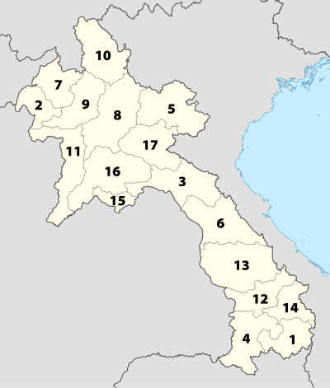

Number | State | Capital | Area (km²) | Population
1 | Attapeu | Attapeu | 10,320 | 114,300
2 | Bokeo | Ban Houayxay | 6,196 | 149,700
3 | Bolikhamsai | Paksan | 14,863 | 214,900
4 | Champasak | Pakse | 15,415 | 575,600
5 | Hua Phan | Xam Neua | 16,500 | 322,200
6 | Khammouane | Thakhek | 16,315 | 358,800
7 | Luang Namtha | Luang Namtha | 9,325 | 150,100
8 | Luang Phrabang | Luang Phrabang | 16,875 | 408,800
9 | Oudomxay | Muang Xay | 15,370 | 275,300
10 | Phongsali | Phongsali | 16,270 | 199,900
11 | Sayabouly | Sayabouly | 16,389 | 382,200
12 | Salavan | Salavan | 10,691 | 336,600
13 | Savannakhet | Savannakhet | 21,774 | 721,500
14 | Sekong | Sekong | 7,665 | 83,600
15 | Vientiane | Vientiane | 3,920 | 726,000
16 | Vientiane | Muang Phon-Hong | 15,927 | 373,700
17 | Xieng Khouang | Phonsavan | 15,880 | 37,507

Contact Information

Center for Medical Rehabilitation
Dr. Khamphet Manivong, CMR Director
Mr. Thonglith Sihabandith, CMR Deputy Director
Khouvieng Road
PO box 5030, Vientiane Capital
Tel: (856-21) 21-4044
Mob: (856-20) 552-6231
Email: tchtinre@laotel.com

COPE
Kerryn Clarke, Project Coordintor
Cody McDonald, Orthotist Mentor
Khouvieng Road
PO Box 6652, Vientiane
Tel: (856-21) 218-427
Email: cope.project.coordinator@gmail.com

Handicap International
Anne Rouve Khiev, Country Director
Caroline Guerin, Rights and Inclusion Officer
51/1 Hong Kae Road
Ban Sisangvone
PO Box 2496, Vientiane
Tel: (856-21) 412-110 or 451-298
Mob: (856-20) 2203-5112
Email: direction@laos.handicap.be

Lao Disabled People’s Association
Bounvien Louangyot, President
Seebounheung Rd
Thongsanang Village, Chantabuli Dist.
Vientiane
Tel: (856-21) 241-556/7

National Regulatory Authority
Earl Turcotte, UNDP Chief Tech Advisor
Phil Bean, TA Operations/QM
Bountao Chanthavongsa, VA Officer
Courtney Innes, VA Advisor
Ban Sisangvone, Saysattha District
PO Box 7261, Vientiane
Tel: (856-21) 262386
Mob: (856-20) 7801-3056
Email: Courtney-innes@hotmail.com

Jomo Bakery Cafe
Jeff Spohr, Country Manager
Tel: (856-21) 412-792
Mob: (856-20) 7785-3665
Email: jeff@jomo.biz

CMR Wheelchair
Phimphisane Keolangsy, Chief Wheelchair Service
Khouvieng Road
Sisattanak District, Vientiane
Tel: (856-21) 241-467
Mob: (856-20) 5995-2712
Email: nrc_wheelchair@gmail.com

Mike Boddington
Chairman, POWER International
Board Member, COPE
Expert in Disability and Rehabilitation
Mob: (856-20) 5561-0500
Email: mbodd@laopdr.com

University of Health Sciences
Bouathep Phoumindr, Vice Dean
Faculty of Medical Technologies
Head of Rehabilitation Medicine Department
PO Box 7444, Vientiane
Tel: (856-21) 214-032
Mob: (856-20) 5541-1088
Email: bouathep@hotmail.com

World Education
Mark Gorman, Country Director
PO box 6782, Vientiane
Tel: (856-21) 214-524 or 222-439
Mob: (856-20) 5411-9544
Email: markgwel@gmail.com

Mr. Seng Aloun Luangraj
Deputy Head, National Coordination Office
For Disabled People and Elderly
Tel: (856-21) 213-006, 250-131
Mob: (856-20) 559-32388
Email: sengaroun888@yahoo.com

Lao PDR Unexploded Ordnance Sector Overview, September 2012.
Prime Ministerial Decree Resolution 18 referred to it as a Commission; Resolution 061 further elaborated the role and changed the name to Committee.
With support from Handicap International.
This well-researched document was written by Mike Boddington; a draft was shared with Sue Eitel. This has not been officially released or ratified by the NRA.
World Education provided a hard copy of the report during the visit.
There are over 10,000 schools (all levels) in Lao PDR.

